How is Russ the Bus and Taylor Swift in Sync?
“Books train your imagination to think big.” Taylor Swift. “Russ the Bus inspires an early love of reading in children that lasts a lifetime”. Russ.
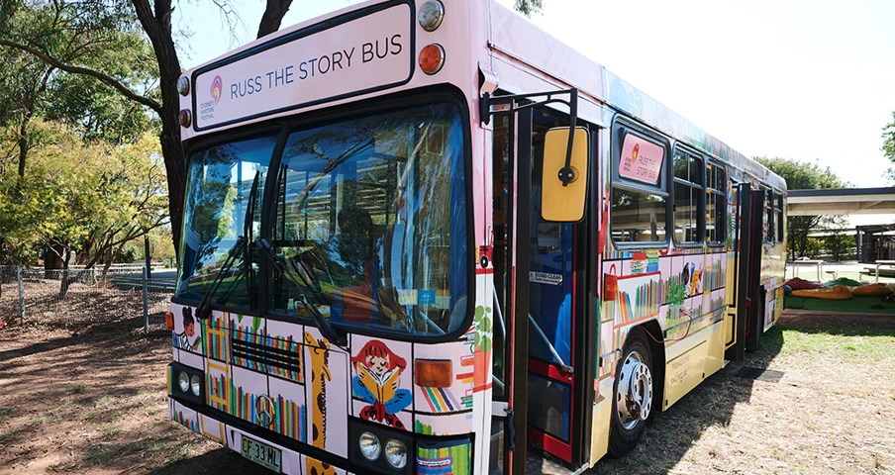
Russ the Story Bus and Taylor Swift agree that - “If you are going to get anywhere in life, you have to read a lot of books.” Roald Dahl.
High profile authors are on board Russ as the Bus as it drives books to kids. Operated by the Sydney Writers’ Festival (SWF), it’s a vibrant initiative designed to promote literacy and a love of storytelling among primary school children across New South Wales.
Meet authors like Susanne Gervay and her famous I Am Jack anti-bullying books, Kristin Darrell and her famous Football Australia’s Matildas and Socceroos story in her Football Australia books, Jules Faber’s famous Weirdo books, Nathan Luff with his hilarious Nerd Herd series.

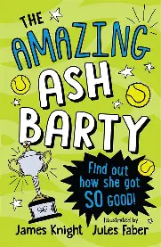
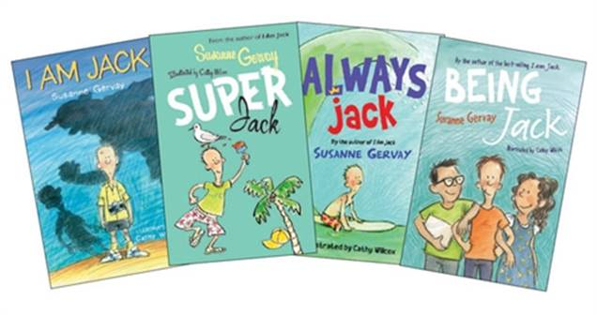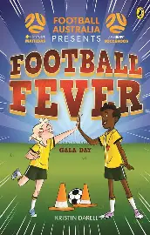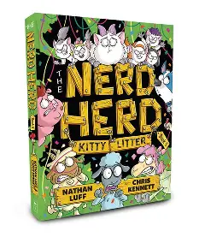
Russ is a retired school bus transformed into a colourful, interactive space filled with books for children to explore. It is part of the Sydney Writers’ Festival outreach efforts to bring literature to communities that may not have easy access to cultural events. Visits schools across NSW and ACT with free book giveaways. Each child gets to choose a brand-new book to take home, and they’re encouraged to swap a preloved book for a new one. There is an audiobook experience: Russ is equipped with headphones so kids can listen to audiobooks during their visit.
Designed by Lava, the interior was crafted to be engaging, durable, and kid-friendly, with over 125 plywood shelves and space for 20 children at a time.
This the 10th years of Russ the Bus, reaching over 10,000 students a year. Russ has become a memorable experience for many children, often cited as a highlight of their school years.
Russ the Story Bus needs some help as its engine is getting very old. Donate to Russ the Bus at Sydney Writers' Festival - Contact Us

