We are family- Adopted, Step, Mixed Ethnicities, Same Sex, IVF, Migrant, Single … Diverse

Guess How I Was Born’ by Susanne Gervay illustrated by Carolyn Daly

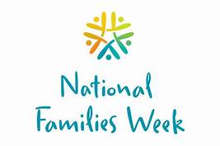
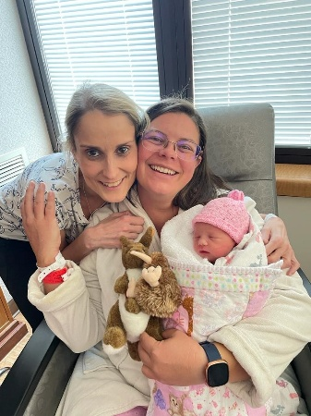
The educational curriculum says it all. The community says it all. Australia voted for same sex marriage 2017. Every family counts whatever way it happens.

Susanne Gervay OAM was a single parent. Her daughter Tory has a loved IVF baby called Violet Rose. Kidney disease made surrogacy with all its risks, her daughter’s journey. Here is Tory with Misty her surrogate and newborn Violet Rose.

As a specialist in child growth & development, Gervay says to talk to children - ‘Keep it early. Keep it simple. Keep it direct. Keep it honest. Keep it diverse. Whatever way families are formed, they are our families. ’

That’s why Gervay broke the mould. This is the first picture book about the diversity of our families – Guess How I Was Born (published Larrikin House)
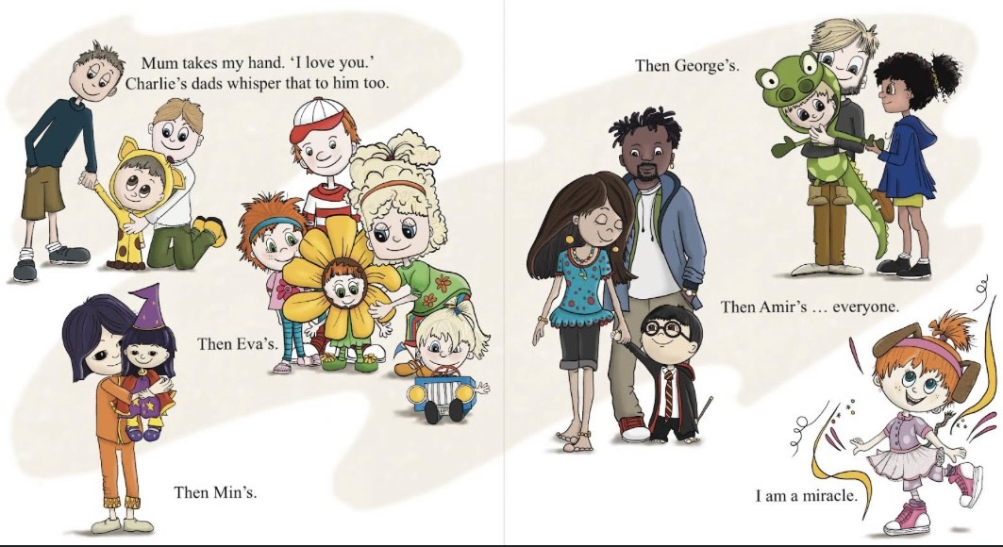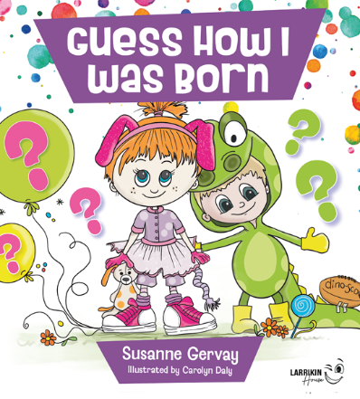

Lending A Hand To Thrive: Supporting Each Other
Each year, thousands of people and hundreds of organisations around the country come together for Australia’s annual celebration of families National Families Week (May each year).
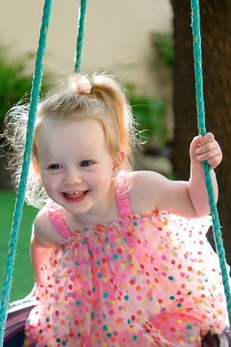
National Families Week is a time to celebrate with your family, connect with your extended family and friends, and share in the enjoyment of family activities within the wider community. No matter where you live – in our major cities or a remote community in the country – all Australians, including community organisations, schools, councils, companies and individuals are invited to participate in National Families Week each year.
The aim of National Families Week is to not only celebrate the vital role that families play in Australian society, but to also reflect on the critical role that families play in teaching, supporting and nurturing children as they grow.
National Families Week coincides with the United Nations International Day of Families on 15 May. This day is observed by the United Nations to mark the importance that the international community places on families as the most fundamental units of society, as well as to show concern about their situation in many parts of the world.
It’s an opportunity to reflect on the strength of family bonds, reconnect with loved ones, and embrace activities that bring us together. No matter what family looks like for you, let’s celebrate the power of support and the difference we can make for each other.
Like all the special families, it is us.

Author Susanne Gervay
Susanne Gervay OAM is an educational consultant & writes for young people. Presented the Lifetime Social Justice Literature Award for her body of work by the International Literacy Association, she is an ambassador for many literacy campaigns. https://sgervay.com
Illustrator Carolyn Daley
Carolyn is a visual storyteller, an illustrator and a writer. Carolyn Daly is the creative mind behind Doodle and Design. https://www.doodleanddesign.com.au
Published by Larrikin House ISBN 9781923345102

