I AM JACK in Italy at last.

It took 25 years for ‘I AM JACK’ to reach Italy and is expanding into Europe.

The prestigious American magazine "CIO Look" latest cover for Prof. Daniele Manni of Salento, a true leader and pioneer in the field of education. In a context where prominent Chinese, American, Australian and Arab figures dominate the scene, Manni emerges as an Italian icon among the “10 Most Visionary Leaders Transforming Education”

Daniele Manni and the school, a leader capable of transforming it
Manni's presence on the cover of "CIO Look" marks an epochal moment, as it represents the first time that the prestigious magazine dedicates its cover to an Italian professional. Working with Mabasta, Mammi advocates for youth action that began in 2016 responding to a 12 year girl who tried to commit suicide.
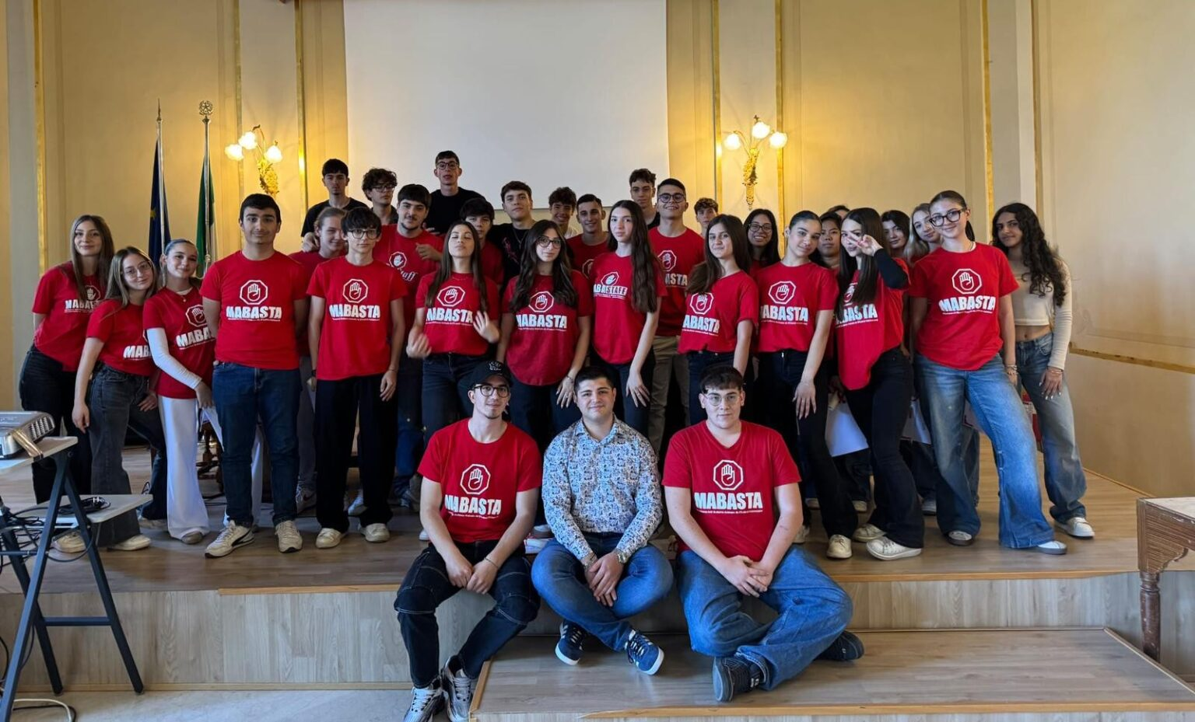
These Mabasta kids are so impressive. Mabasta is a movement of boys and girls, between 14 and 17 years old, founded by Mirko Cazzato in 2016, that fights against bullying and cyberbullying in schools. In 2018, the "Mabasta Model" was developed where the young people of Mabasta act "from below" and make the students themselves active actors in school, with the support of experienced teachers.
In the last 2 years, Mabasta have reached over 800 classes and over 80 thousand students.
The founder Mirko was the only Italian and European in the Top 10 of the Global Student Prize Award, which is a "Nobel" prize for youth impacting the world. The students have been recognised in Italy and Europe and met the Prime Minister of Italy, the Pope and even Spider Man. Supported by countless organisations it is leading anti-school bullying. (See at the end of release)
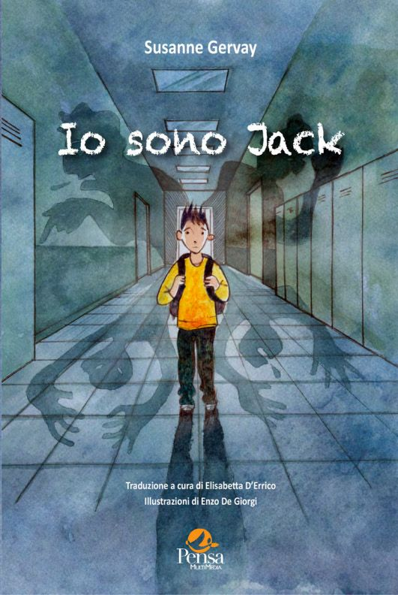
Under the guidance of computer science professor Daniele Manni, the team adopted the "Mabasta Model" to prevent, combat and debully every class in Italy from all forms of bullying, cyberbullying, bodyshaming and sexting. This model stands out for its flexibility, which can be adapted to both individual classes and entire schools, with a particular emphasis on the active participation of students. The strategy is further characterised by its affordability, allowing schools to access a wide range of information resources, forms and questionnaires free of charge.
