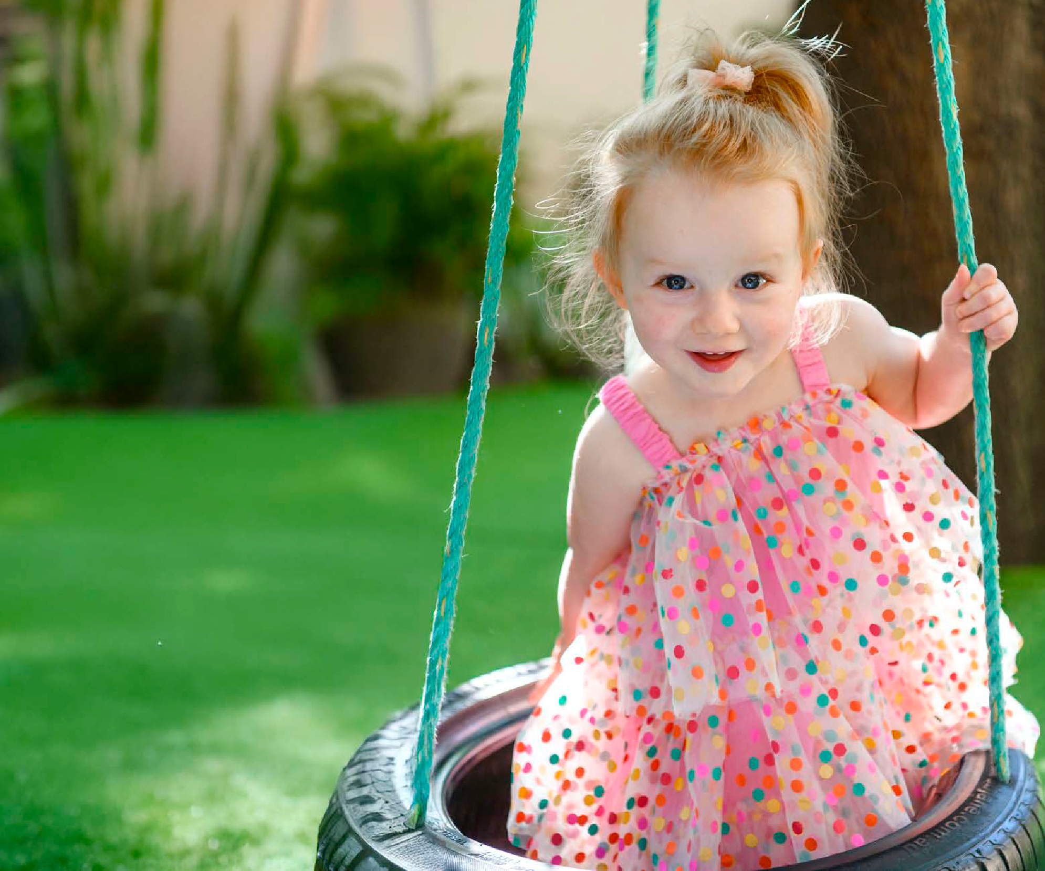
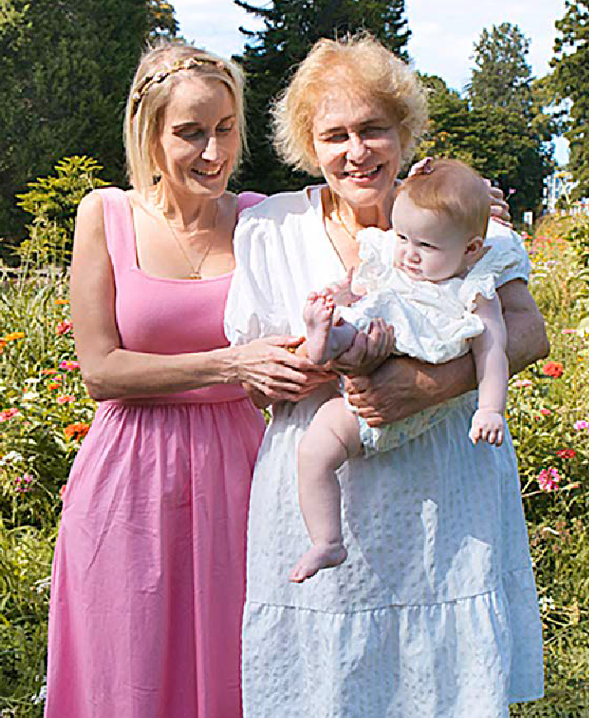
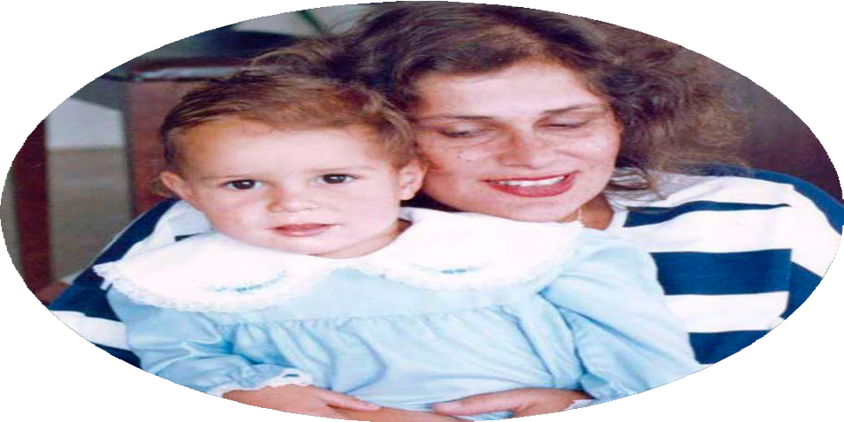
Real life

Tory and Susanne dote over Violet!

an American clinic known for success with complex cases.
The mother-daughter duo pored over countless sperm donor profiles online until they agreed on a handsome suitor.
The surrogacy agency then matched them with Misty, a compassionate mother of three, and an online friendship quickly blossomed.

A LONG JOURNEY
After an intense year of medical evaluations, psychological testing and red tape, Tory finally flew to America for her egg extraction in 2021.
Susanne recalls the pain of not being able to accompany her daughter on the journey from Sydney due to Covid travel restrictions.
“I spoke to her every day, and I’ll never forget the night she called and said, ‘Mum, we’re having a baby,’” Susanne says. “I nearly dropped the phone, and I couldn’t stop sobbing.
She had been through so much and she deserved it so much.”
When Tory returned home, the pair waited on tenterhooks for weekly pregnancy updates from Misty.
They had just learned that a baby girl was on the way and were preparing for a
“babymoon” in America when Susanne began feeling dizzy and occasionally slurred her words.
A CT scan revealed a 6cm tumour in Susanne’s brain – but that was only the
beginning of the

Tory’s surrogate Misty.

how we’d made a pact to raise her together,” Susanne says. “I was determined to keep my
Tory says Violet is an absolute joy.
promise, so I struggled through hours of occupational therapy, speech therapy and physio.
“Two months later, doctors advised me against flying, but I wasn’t missing the birth for the world.”

‘Tory wanted a baby
more than anything’

Tory had just landed in Los Angeles a month before the baby’s due date when Misty called telling her she had gone into early labour.
In a race against time, Tory

stared at me wide-eyed for an hour. Mum arrived four hours later, and we just cried and doted over our tiny, precious little miracle.”

CHEEKY CHATTERBOX
Their shared household has been a whirlwind ever since, juggling the demands of motherhood, while Susanne underwent a second brain surgery and Tory become gravely ill before finally receiving a kidney transplant in January. Despite the mountain of challenges they have faced, the pair dote on their “cheeky little chatterbox”, who has a kind, friendly nature and loves to make people laugh.
Their unique journey inspired Susanne to write her latest
children’s book Guess How

A precious pact turned Tory’s dream into reality
FAMILY’
MIRACLE
‘OUR

W
nightmare ahead. After hours of invasive surgery, doctors discovered
not one, but two
moved heaven and earth to get to the hospital, making it just in time to be by Misty’s side as her precious daughter, Violet Rose, entered the world weighing
I Was Born, which was released on Global Parents Day.
Told through the eyes of Violet, the story highlights different family structures and

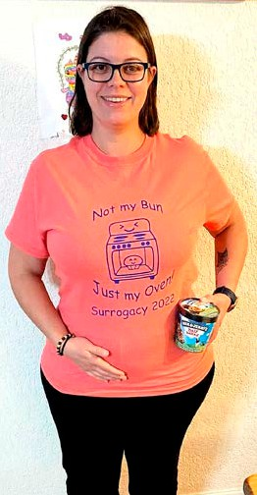
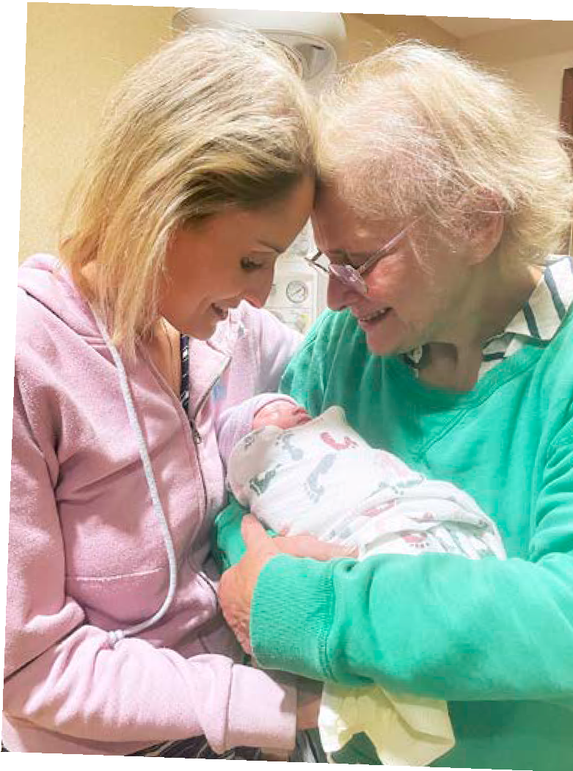
atching little Violet Rose as she laughs while being pushed on a swing at the
Words: Megan Rowe.
local park, Tory and Susanne Gervay are overcome with unconditional love.
The little girl’s mum and grandmother treasure these simple moments every day as
36 WD
they jointly raise the almost three-year-old, whose arrival in the world was anything but simple.
“She is an absolute joy,” Tory tells Woman’s Day, as her mother, Susanne, gently reflects on their emotional journey that began back in 2017.
Violet looks just like Tory and Susanne.
At the time, 30-year-old Tory
was battling stage-four kidney failure when she was struck by an intense and unexpected longing to become a mother.
“Tory wanted a baby more than anything but feared being a solo parent, so we made a pact to raise her child together,” Susanne, 72, explains. “Carrying a child herself was too risky due
to her health so the plan was to extract her eggs and then use a surrogate.
“Over the next six years, I was by her side during eight failed IVF attempts as sadly, none of her eggs were viable.”
Determined to fulfil her daughter’s wish, Susanne found
brain tumours, and she had suffered
a stroke during the ordeal.
Susanne lost her ability to speak, to read, and could
barely walk.
“All I could think about was Tory’s baby girl and
just 2.4kg.
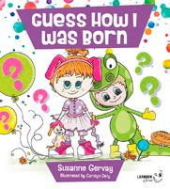
“I literally walked into theatre and saw Misty push three times before pulling the baby out herself,” Tory, 38, says. “A nurse placed Violet on my chest, and she just
embraces the many ways
children come into the world. “In Guess How I Was Born all families matter – adopted, stepchildren,
LGBTQ, mixed ethnicities, nuclear and IVF families.”
WD 37

