Bridging Cultures: Susanne Gervay’s literary journey with India
By Indira Laisram

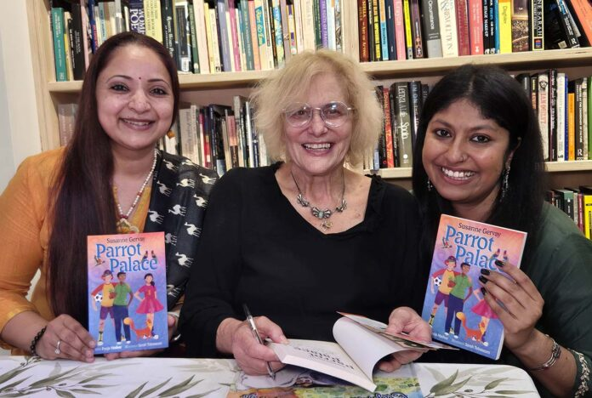Parrot Palace launch
About a decade ago, Susanne Gervay OAM, visited India to speak at the University of Delhi and to participate in an international conference between India and Australia. Like many first-time visitors, Gervay found India “excitable” and full of energy. But one experience stood out for her. “India really got into my head. It left such a profound impression on me that when I returned to Australia, my daughter-in-law was planning her wedding to my son. She was discussing what everyone should wear, and I said, ‘Well, I’m wearing a sari,’” Gervay recalls with a laugh.

What struck Gervay most was India’s deep connection to philosophy. She found their discussions on philosophy and humanity’s future fascinating. While she visited iconic sites like the Taj Mahal and the Red Fort, what stayed with her was the warmth and acceptance she felt—a sense that everyone belonged.
Back in Sydney, Gervay became involved with the Indian Consulate, exploring ways to unite the arts of India and Australia through workshops for a diverse community. “I formed deep friendships with many of the people I met, and I began engaging with India in a truly meaningful way,” she says.
But amid all this, Gervay—an award-winning author with accolades including the University of Technology Alumni Excellence Award, the Lady Cutler Award for Distinguished Services to Children’s Literature, and multiple Notable Awards from the Children’s Book Council of Australia—noticed that Indian children, despite being the second-largest immigrant group in Australia, lacked a “strong voice” in literature. 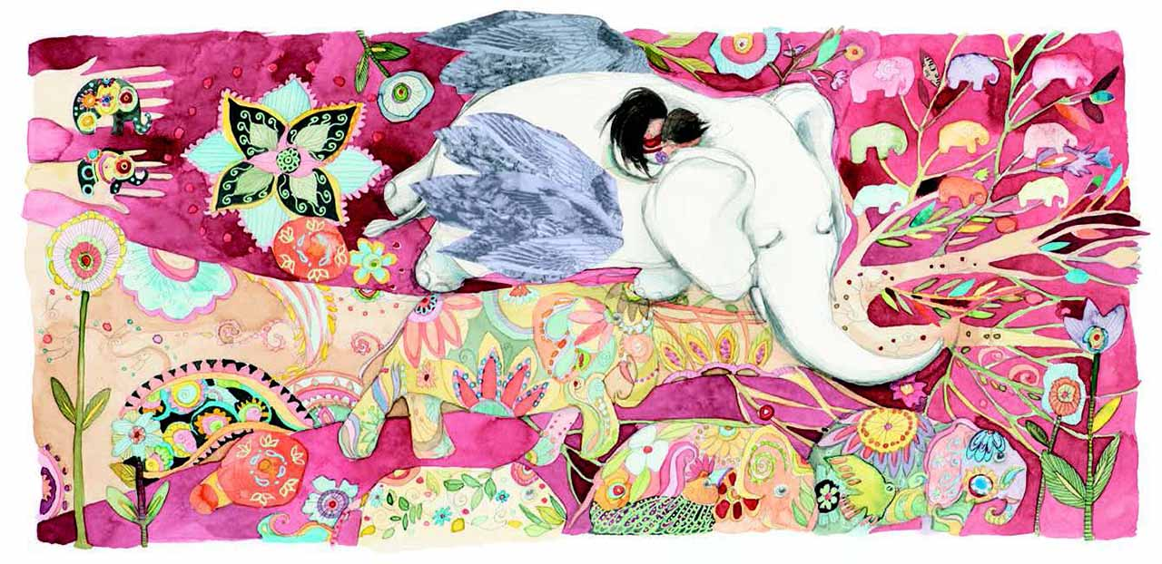
“I wanted to write something for them—for those kids and for all of us,” she says.
The result is Elephants Have Wings (2018) and the Parrot Palace (2025), two books that celebrate her connection with India. Gervay will be sharing these works at an event organised by the High Commission of India and the Swami Vivekananda Cultural Centre and Cowra Council, NSW, during Harmony Week (March 17–23).
Elephants Have Wings is a unique interfaith picture book, illustrated by Anna Pignataro, that promotes social inclusion. Two children ride a mystical white elephant to explore the parable of the blind men. As they encounter war and climate change, they find hope and unity in humanity, with the parable resonating across Hinduism, Jainism, Buddhism, Sufism, and modern philosophy.
The book has received great reviews, with Professor D.R. Pattanaik of Banaras Hindu University, India, describing it as “demonstrating with great power that we can teach our children profound truths and timeless values.”
Gervay says that this book further inspired her to write Parrot Palace, a junior fiction novel that invites readers into a multicultural, inclusive world where differences are celebrated.
In Parrot Palace, three kids—Hari, Lily-Rosa, and Mikey—live in a vibrant apartment block, exploring cultural traditions, dealing with their grumpy neighbour Mr. Crabtree, and learning about inclusion and acceptance.
Gervay explains that her personal background deeply influenced the creation of Parrot Palace. “Diversity, inclusion, and my family inspired this story,” she says. “My family is from Hungary, and my nephew married a Chinese-Australian woman. Naturally, Parrot Palace includes a Hungarian-Chinese girl, reflecting our blended world.”
To ensure authenticity, Gervay collaborated with Pooja Mathur, a multi-award-winning teacher-librarian, who helped make the story feel true and real. Illustrator Sarah Tabassum brought a playful touch to the book, with her cheeky depictions of Hari, who has a little crush on Lily-Rosa. Tabassum’s vibrant parrots soar across the cover, infusing Parrot Palace with joy and life.
“I also wanted to use this book to introduce Indian culture to Australia. Australia is increasingly engaging with Indian culture—we’ve seen the Opera House lit up with vibrant Diwali colours. I’ve been invited to present at the Powerhouse Museum and the Art Gallery of New South Wales, where I’ve discussed how my books encourage not only Indian Australians but all young people and their diverse families to explore Indian culture,” says Gervay.
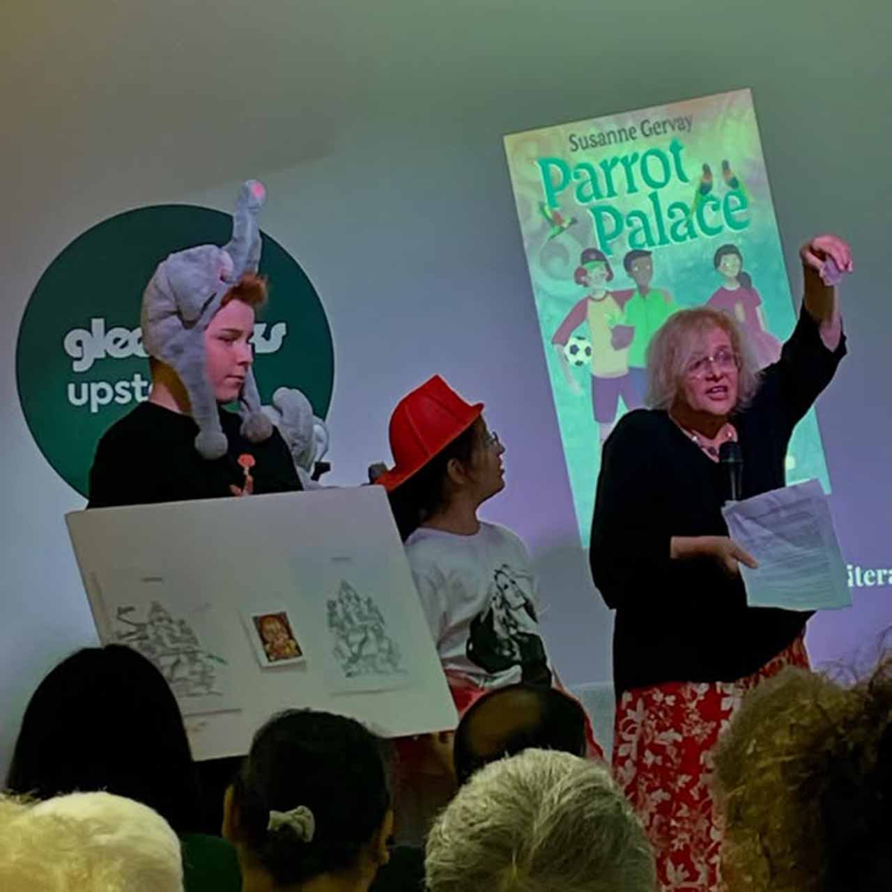
She adds, “Many kids are unfamiliar with certain aspects of Indian culture, like taking off their shoes when entering an Indian home or understanding traditions like Diwali. These little details become part of the journey in the story, helping readers learn and connect with a culture that might be new to them.”
Gervay follows Shakespeare’s approach to storytelling. “Even in his most intense and confronting dramas, he always used humour. Similarly, I always weave humour into my books. It helps children engage with deeper themes in a way that feels natural and enjoyable.”
And as a specialist in child development, she understands the importance of making stories relatable. “Children make me laugh. They’re so funny. I jot those moments down because they don’t realise how funny they are.”
Beyond children’s literature, Gervay has contributed to adult anthologies, including a collaborative project with Indian and Australian authors, edited by Meenakshi Bharat and Sharon Rundle. The anthology explored themes of borders—both physical and personal—and featured luminaries like Salman Rushdie, Kate Grenville, and David Malouf.
Yet, her true passion lies in writing for children. “If we don’t reach the kids, how do we change the world?” she asks. “Children need their minds opened. I won’t tell them what to think, but I want to encourage them to start thinking.”
Gervay’s commitment to multiculturalism is deeply personal. “My parents came here as refugees, and they built a life here. I am grateful every day that I’ve been accepted in this country and had the opportunity to get an education, allowing me to be all that I can be.”
She sees this as part of a larger picture. “I don’t see myself as the only person who has come to this country—I welcome all immigrants who contribute to building our nation. They bring richness that becomes part of our food, culture, art, and more. But what unites us all is our shared commitment to democracy and the responsibility it entails: to give back to others.” Susanne Gervay

