Teacher’s Notes for Parrot Palace by Susanne Gervay
with Pooja Mathur and illustrator Sarah Tabassum

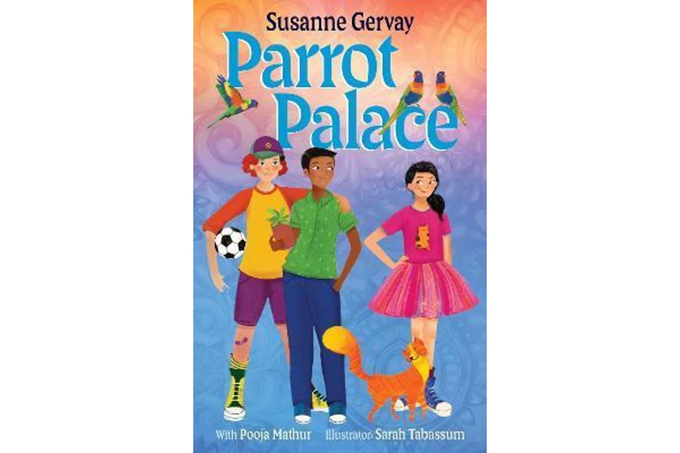

Synopsis

Three inventive, daring kids and their diverse families, live in a three-level apartment block called Parrot Palace. There are lots of parrots there, but their main goal is to create a squad of mates.

Hari, Lily-Rosa and Mikey share their secrets. Is Mikey going to become a joker or a builder like his Dad? Or is Lily-Rosa really going to be a firefighter or ballerina or defend her Opa because he is a home father? Or is Hari going to fix the disaster he created for his Nani and mother?

They join together and confront their arch enemy, the neighbour Mr Crabtree. It is here, that they eventually find the real answers to friendship.

Australia has many diverse families.
In this narrative there are: the stay-at-home dad (Hungarian) who minds two kids and play the violin, while the mother (Chinese) works as a pre-school director; a sole parent (deceased father), Indian family with a mother who is a nurse and the Indian grandmother the homemaker; a nuclear family, with forebears here for many generations, and an (implied IVF) baby to be born soon.
Key Concepts:
- Diversity
- Acceptance and inclusivity
- Bullying/Confronting bullying
- Assertiveness
- Cross-cultural perspectives – Indian sub continent,
Hungarian, Chinese, Aussie
- Community
- Relationships with Family and Friends

Writing Style
Susanne Gervay’s style is deceptively simple. Easy to engage with, the narrative is fast paced with lively dialogue, humour and incidents that creates a page-turning reading experience. While Parrot Palace is an entertaining book, there are deeper stories within the narrative including diverse families, resolution of bullying, mateship and friendship. It’s significant that kids from different cultures become best friends. Even more than that, it invites children, families and community to get along.

The use of first person, present tense, told from Hari’s point of view immediately engages readers in Hari, Lily-Risa and Mikey’s life. These are great kids with great families which you will love.

‘Susanne Gervay is rare in her ability to place common problems for children within the spectrum of normal family life. The result is that she makes it OK for children to talk about them.’ The Age.

Extract from the Start of Parrot Palace
Chapter 1
Google-Eyes
Hari is the name of a lion in India. He defends his territory and protects his family. That’s my name too.

It was the greatest day in my life when Nani, Mam and I moved into Apartment 2 on the second floor of Parrot Palace. We bonded with Parrot Palace straight away, especially my grandmother Nani. She cried when she put her hand on the green parrot wearing a golden crown. It’s cemented onto the entrance. Nani told me, ‘Parrots are a symbol of love.’ The parrot reminded her of the rose-ringed parrots from India.

Now, I have my very own room. My plant, the lamb’s ear, is in an earthen pot on my windowsill. I stroke its leaves. It feels like a soft pillow. Nani left her lamb’s ear plant in India. It was the last gift from my grandfather to Nani, as his soul left him. When Nani touches the lamb’s ear, she always smiles.

I love my room. I’m making a space shuttle with Lego. Imagine going to Mars? My telescope is set up on my desk so I can see the stars. I used to sleep in Nani’s room. Since she snores, it meant I was always a bit tired. She also lets out fluffy farts all night. But I never told Nani about her snoring or fluffy farts. I didn’t want to make her worry. So, I slept with the blanket over my head. But in summer it’s very hot. I just couldn’t sleep with a blanket over my head all the time. Now I don’t have to.

My mother Mam kisses me goodbye. Tonight, she is on a late shift as a nurse in the hospital. We left India when I was five. There was a call for nurses to work here. Mam had done all the training in India and just did some extra study here. She said it was too hard to live in India without a husband and without a home. I wish my father was here, but he died of a heart attack. He’s now with my grandfather.

Nani’s in the kitchen piling jalebi onto a plate. It takes her hours to cook them. They are my favourite. The crunchy swirling sweets are delicious. My mouth waters.

Doorbell. ‘Rat a tat-tat.’ Nani is a bit deaf. So, I pad to the front door in my bare feet. I creak open the door. Who could it be? Oh, he’s a boy like me. He’s standing there holding a football. His red hair spurts into sausage springs, escaping from his googly-eyed cap.
‘Hi. I’m Mikey. Saw you just moved in. Our club headquarters HQ is at the end of the backyard.’

From my balcony, I’ve seen the wooden hut with the porch right at the end of the yard. I stare at Mikey’s cap with the googly-eyes stuck on the front. The eyeballs spin in zig-zags as he nods his head.

‘I live on the top floor. Hey, what’s your name?’

‘Hari with an ‘i’.’ I don’t know why I say that, but Mikey laughs and the eyeballs spin even more.

‘Well, I’m Mikey with a ‘y’ and I’m eleven.’

‘I’m eleven too.’

Author Inspiration
I love being an Ambassador for Australia. I have embraced country acknowledging the traditional owners of the land who have lived here for 65,000 years. Every year I welcome new Australian citizens. These citizens come from countries such as Brazil, Taiwan, Philippines, India, Bangladesh, Ireland, Vietnam, China, UK, USA, Ukraine, even Hungary and everywhere. Like many, my family came here as refugees, who escaped war and terrorism. Like many from the world, people make a new life in a democratic multi-cultural nation. I bring this ethos in the celebration of our diverse nation.
I have become involved with the subcontinent of India. I presented at the IASA Conference in Goa, as well at the University of Delhi and the British Consulate Delhi. My short stories were included in the adult Indian-Australian anthologies edited by Dr Sharon Rundle and Professor Meenakshi Bharat which include the works of David Malouf, Sir Salmon Rushie, Tom Kenneally. As Master of Ceremonies at the Writers Forum at the Indian Consulate Sydney I welcomed diverse speakers.

However, my true love is children’s and young adult stories for young people. I loved reading my picture book inspired by the Indian subcontinent Elephants Have Wings at Diwali at the Powerhouse Castle Hill (Sydney). I also read it at the Art Gallery of NSW for Diwali the year before. Parrot Palace is a special book that encapsulated friendships of kids – Hari with his Indian sole parent family and Nani; Lily-Rosa with her Hungarian dad and Chinese mother (like my family); and our Dinky-di Mikey.
The talented is Sarah Tabassum from Bangladesh in the Indian subcontinent, illustrated Parrot Palace. It is her first book. Pooja Mathur born in India was the invaluable advisor and extraordinarily talented as head librarian.

Study Notes
Education Applicability
Using literature in teaching is a way of connecting across the curriculum and creating powerful learning experiences. Parrot Palace can be read to achieve reading and viewing literacy outcomes, as well as PDHPE outcomes that address values and attitudes of interpersonal behaviours, especially relating to multi-cultural Australia.

Parrot Palace engages the 'social influences' approach that uses the real social settings and experiences of students, schools and families, to teach and practice social skills in decision-making, communication, negotiation and peer resistance and refusal, as well as providing accurate information for positive choices.

What is Harmony Week?

https://www.harmony.gov.au
It is a time to celebrate Australian multiculturalism, and the successful integration of migrants into our community. Australia is one of the most successful multicultural countries in the world and we should celebrate this and work to maintain it.
Harmony Week is about inclusiveness, respect and belonging for all Australians, regardless of cultural or linguistic background, united by a set of core Australian values. Parrot Palace is central to this.

Classroom discussion and activities

- Can you judge a book by its cover?
After looking at the cover, blurb and contents of Parrot Palace, students are asked to write down what they think the story is about and what they expect they might learn.

- Do you like the kids in Parrot Palace. Are they similar to anyone you know?
Discuss the characters and find out if they remind you of people you know. Could Hari, Lily-Rosa and Mikey and/or their families be your friends?

- How do you feel about grandparents like Nani. What can they share with you? How can they help you? How can they annoy you too? But do you love them? How and why?

- How would you deal with bullying? What could Hari do? Some examples, are below:

- Be silent and accept bullying.
- Hide.
- Find new friends.
- Stand up with friends to bullying.

- Do you think Hari likes Lily-Rosa? How do you know? She gets defensive about her dad. How does Hari react? Can there be misunderstandings between friends. How can you fix them?

  - Are Mikey and Hari friends? How do you know?

6. Can kids influence others?
- How do Hari, Lily-Rosa, Mikey influence each other?
- What does friendship mean?
- Have you an example of why you followed a friend to do something, both good and bad?
- What would you like to influence others to do?

You can find out more about Susanne on her Website – sgervay.com

For more Teaching Notes – go to Parrot Palace - www.bigskypublishing.com.au

