Daisy Sunshine, by Susanne Gervay
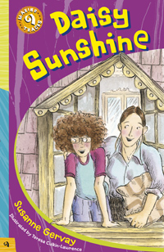
Synopsis
When Daisy's dad loses his job and leaves home, Daisy and her mum end up at the Grand Private Hotel. The hotel is run by Mr and Mrs Papadopolous and their daughter Nina, who is 11, just like Daisy. The Papadopolous family take the pair in; Daisy is soon fascinated by the hotel and its guests. One in particular excites and inspires Daisy: Rainbow Rose, a young, free-spirited and determined woman. Daisy and Rose soon form a friendship that will help to change Daisy's life.
As Daisy's mum takes up cleaning work at the hotel and seamstress jobs to supplement her meagre income, Daisy is drawn into the heady atmosphere of the 1975 International Women's Year. Through Rainbow Rose, Daisy learns of the groundswell among women across the world campaigning for equality at home and in the workplace.
The energy and excitement of the women's liberation movement sweeps Daisy up; she is soon keen to participate in the march planned for Saturday 8 March. Meeting resistance from her mum, Daisy becomes frustrated. She clashes with her mum; however, the clash is soon over and actually serves to bring them closer together. Daisy is eventually given permission to join the march. Mr and Mrs Papadopolous allow Nina to join in and guests at the hotel, like Vietnam War veteran the Colonel and roly-poly Old Dot, are soon helping with preparations.
Being a part of the march helps Daisy see a world of possibilities instead of limitations:
- 1975 is turning out to be much better for Daisy, her mum, Rainbow Rose and many women across the world.

Discussion questions
- What prompted Rainbow Rose to add 'Sunshine' to Daisy's name? Why did Rose add 'Rainbow' to her name? What descriptive word would you add to your name and why would you choose that word?

- Daisy urges her mum to study accounting at night classes; however, her mum thinks she's 'not good enough'. Why would Daisy's mum feel that way? What would you say to Daisy's mum to encourage her to study accounting?
- Rainbow Rose's room at the Grand Private Hotel is decorated with scarves, crystals, velvet pillows, women's liberation and anti-Vietnam War posters, and vinyl records of bands such as the Beatles. What does her room say about her personality? Think about what's in your room at home: what does it say about your personality?
- Rainbow Rose describes International Women's Year in 1975 as a 'new beginning'. What does she mean by that? What circumstances might have contributed to the declaration of International Women's Year? What were women across the world
- do to reduce the emotional stress of doing that?
- Explain why Daisy is attracted to the piece of chiffon material in the shop. Why does she hoping to achieve in that year?
- Mr and Mrs Papadopolous are from Greece. Suggest why they left Greece and settled in Australia. What would be some of the challenges they faced upon arriving in Australia? How would you feel if your family moved to another country? What would you choose to wear it as a scarf? Chiffon is a lightweight see-through fabric. Apart from using it as a scarf, what else might Daisy have done with the piece of chiffon?
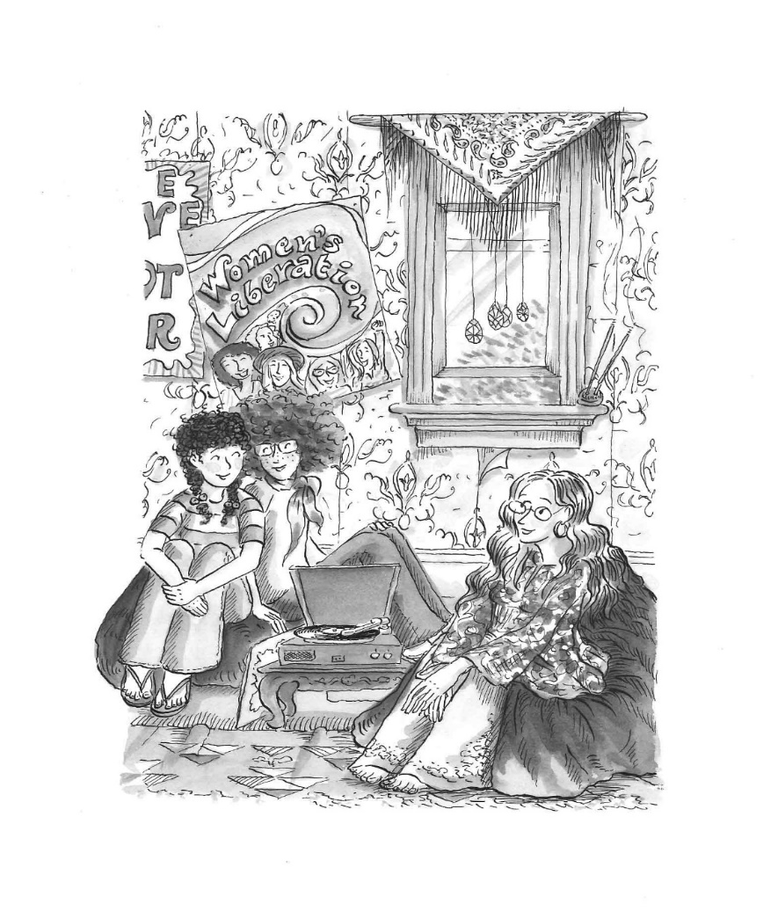

Classroom activities
1. Write a song
- Daisy writes a song to sing while participating in the International Women's Year march. Ask your students to choose a contemporary topic and write a song on that topic, working in small groups.
- Have them consider songwriting aspects such as style, instrumentation, tempo, timbre (the sound characteristics of instruments), harmony, rhythm and melody.
- If possible, have your students record their songs so that they may listen to them later on and compare them to other songs written in the class.
2. Create a drama piece
- Rainbow Rose goes away to participate in protests aimed at saving old buildings from destruction. Ask your students to create a drama piece based upon the scene of a similar protest at an old building.
- Have them consider the characters required (eg protesters, demolition team and city council representatives), the use of costumes, props and make-up, the nature of the conflict and how it might be resolved.
- If possible, have your students videotape the performance so that they may analyse how it expressed their interpretation of the theme.
- Encourage them to research as part of their preparation the 'Green Bans' that were a substantial part of the 'anti-heritage building demolition' movement in the 1970s in Australia.
These websites may be useful for research:
- Teaching Heritage – www.teachingheritage.nsw.edu.au/
- ABC – abc.net.au/rn/science/earth/stories/s18145.htm
3. Research the history of women at work
- Include topics such as pay rates for women and men, number of women in head and company president positions, maternity leave conditions, part-time work and women in 'traditionally male' occupations.
- Compare women's work conditions of 1975 and today.
These websites may be useful sources of information:
- Australian Human Rights Commission – hreoc.gov.au
- Office for Women – fahcsia.gov.au/sa/women/overview/ofw
4. Hold a class debate
- Daisy is inspired by one of Rainbow Rose's posters; it says 'Believe in your freedom'. Ask your students to hold a class debate using the poster theme as the debate topic.
5. Create a t-shirt design
- Daisy and her mum create their 'Superwoman' t-shirts to wear in the march. Ask your students to create a t-shirt design that Daisy and her mum could have worn in the march.
- Ask them to use the Wear it with pride! (PDF 194kb) for their designs.
- Encourage them to explore t-shirt designs that they might wear if they were to participate in marches related to contemporary current affairs.

Book details
Daisy Sunshine
by Susanne Gervay
illustrated by Teresa Culkin-Lawrence
ISBN 978 1876944 67 4
198mm x 130mm, 64pp
black and white illustrations
Released December 2008

Resources
Collection record – Superwoman T-shirt

