Who’s the gang On our street?

Format: 230mm x 260mm
Author: | Susanne Gervay
Illustrator: | Nancy Bevington
ISBN: | 9781922896803 HB  9781922896810 PB
Publisher: | Big Sky Publishing
Release Date: | September 2023

Pages: 36 pages
Price (incl. GST): $19.99 (HB) $14.99 (PB)

Who are smart, naughty, love playing tricks, flashy, very loud, but need lots of affection? What is an Australian icon, millions of years old, fast and loves to rock and roll?
Another fun and fact filled book from one of Australia’s much-loved authors.

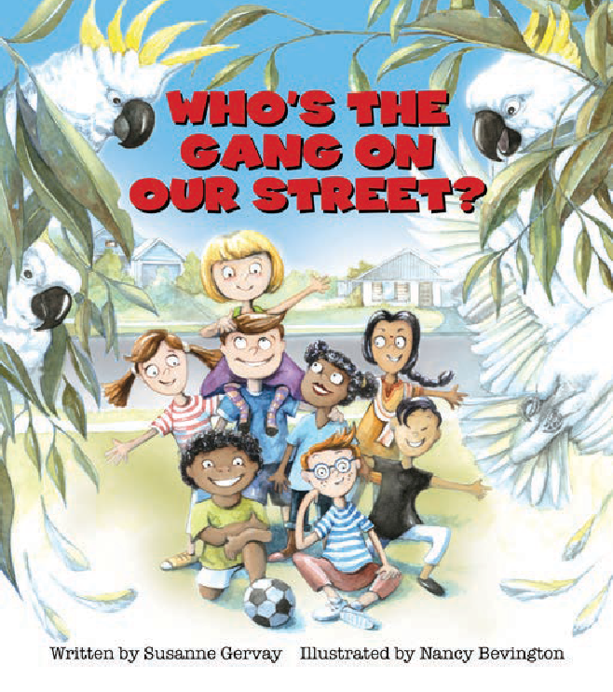Who has funky-punky spikey hair?
Who bops and bounces, dances to a beat and taps their toes?
Who loves snacks and tricks and sharing the fun?
Peek inside to discover the tricks and adventures of one of Australia’s favourite neighbourhood gangs.

Key Selling Points:
- SMILE ALL DAY. Dive into the gorgeous illustrations and rollicking rhythm of naughty, funny, beautiful, heart- warming cockatoos.
- Sulphur-crested cockatoos are a medicine for JOY according to scientific research. When people are ‘blue’, the cockies lift depression and make the world a HAPPY place.
- Quirky facts and rollicking rhythm, as the iconic sulphur- crested cockatoos delight and provide invaluable sharing opportunities for adults and kids.
- What do toddlers and sulphur crested cockatoos in common? They’re smart, tumble, play tricks and make a lot of noise. Share the fun and lessons our lovely cockatoo’s can teach us!

- 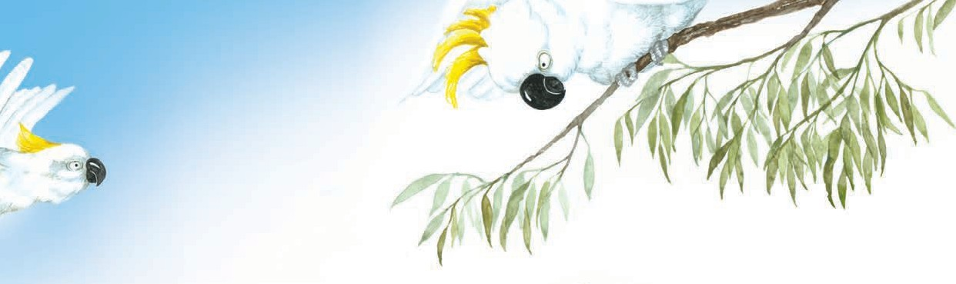Celebrate our Australian wildlife – watch sulphur-crested cockatoos play and live.
- Specific links to Australian Curriculum.

About the Book
Who’s The Gang on Our Street is a narrative non-fiction with supporting facts. It is written to delight young people about the antics and values of our loved sulphur-crested cockatoos. It combines creative imagery and information and is on the K-3 Australian national curriculum for Australian birds. It links into the social and emotional module where the sulphur- crested cockatoos have a social structure which embraces equality, inclusion, no bullying, loyalty and values that relate to the best of what we seek to teach children. They are also funny, playful, affectionate and smart. Sulphur-crested cockatoos are part of Australian identity in both the city and bush.

About the Author
Awarded the Lifetime Social Justice Literature Award for her books by the International Literacy Association, nominated for the Astrid Ingrid Memorial Award and an Order of Australia for literature, Susanne Gervay is recognized for her youth literature from pre-school to young adult novels on social justice. She engages young people in complex issues from multiculturalism, disability to peace.

About the Illustrator
Nancy Bevington is an energetic, multifaceted visual artist. Her artistic career spans over three decades, working in painting, illustration and concept creation and execution. Picture books are one of her real passions. Using her many styles and techniques she has the ability to interpret the written word and bring a story to life.

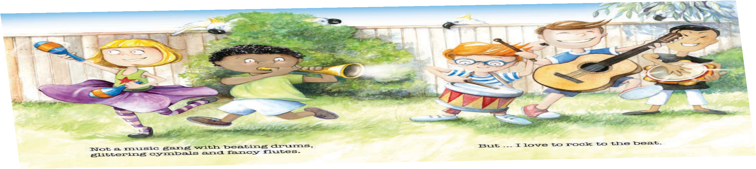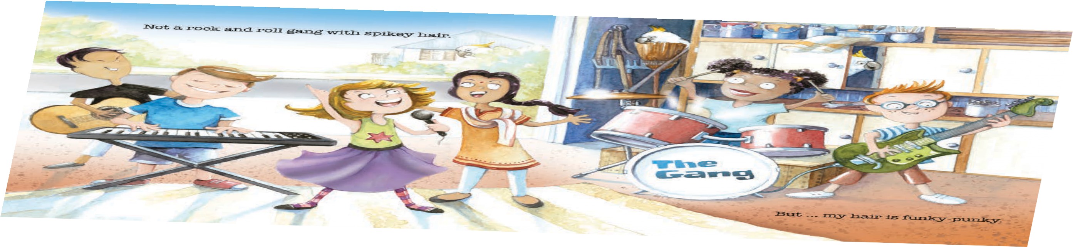
sharo
2023-05-24 01:14:49
--------------------------------------------
0410 332 789

