Sulphur-crested cockatoos: Australian icon
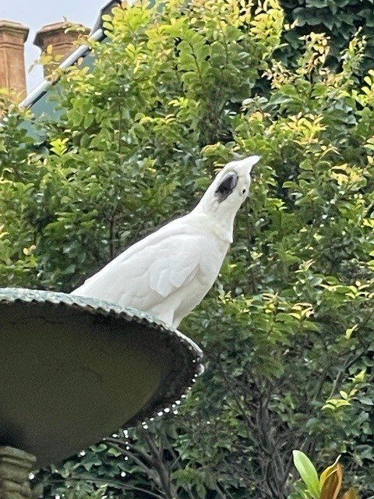

Written by Susanne Gervay and illustrated by Nancy Bevington

What are three creative and joyous charms of Sulphur-crested cockatoos?
- They have real rhythm and share their dance moves with each other.
- These cockatoos are so smart and inquisitive. They have even learnt and teach others to opens bins.
- Sulphur-crested cockatoos are socially complex and ‘marry’ their partner which can last up to 60 years. They love family. Some flocks even have three generations of cockatoos, from grandparents to grandchildren.
https://www.australiangeographic.com.au/topics/wildlife/2021/08/sulphur-crested-cockatoos-australian-icon/
Sulphur-crested cockatoos have travelled the world
Guess where there is a painting of a sulphur created cockatoo, completed by Andrea Mantegna in 1496 in Venice. It is now hanging in the Louvre?
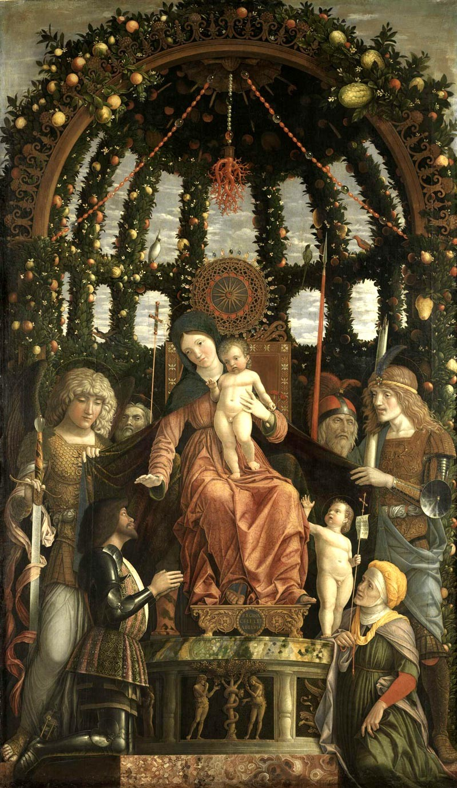
Find the Sulphur-crested cockatoo in the painting!
It is perched above Mary, mother of Jesus. It’s unclear how Mantegna included a bird found in New Guinea and Australia, given that trading routes to Europe were not clearly established at the time. However there are many theories about how the sulphur crested got to there. It could have been transported from Australia or eastern Indonesia via China, as part of a trading route to Europe. The Ming dynasty in China in the 1430s curtailed trade, which forced traders marooned in Indonesia to look to trade into India and the Middle East, which could then go onto Venice. There are other theories.
https://www.sbs.com.au/news/article/renaissance-art-cockie-shakes-up-history
Sulphur-crested Cockatoos
Sulphur-crested cockatoos are native to eastern Australia, New Guinea, Indonesia, and New Zealand. Their preferred habitat is along the edges of tropical and subtropical rainforests.
Sulphur-crested Cockatoos are often found in many countries from Singapore, Palau, Taiwan, Puerto Rico as either introduced species, released or escaped pet birds. Singapore has Sulphur-crested Cockatoos flying around our parks, gardens and estates. Sulphur-crested Cockatoos are no longer permitted to be imported to the United States as a result of the Wild Bird Conservation Act (WBCA). They are in zoos across the world which showcase Sulphur-crested cockatoos.

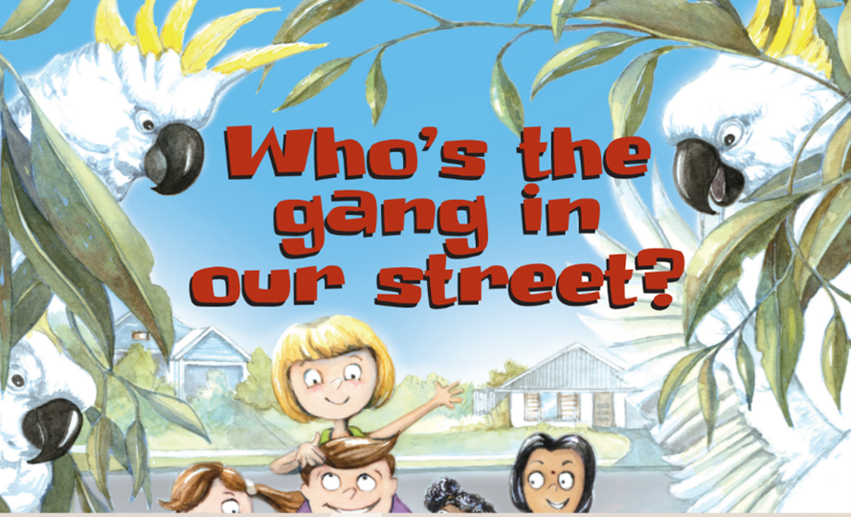
Learn about Sulphur-crested Cockatoos.

Take photos of Sulphur-crested cockatoos

Collect feathers which are left behind

Make a collage of Sulphur-crested cockatoos

- Birds in Backyards https://birdlife.org.au/projects/birds-in-backyards/

- Aussie Bird Count – Teachers page - https://aussiebirdcount.org.au/teachers/

- Nature Australia - https://www.natureaustralia.org.au/what-we-do/our-priorities/wildlife/wildlife-stories/cockatoos-of-australia/

- Animalia – Sulphur-crested cockatoo bio - https://animalia.bio/sulphur-crested-cockatoo

- Bush Heritage - https://www.bushheritage.org.au/species/cockatoos

